PROJECT FILE

Relational Data Base Management Systems
CS- 2113 (Practical Based on CS – 2113)
Session: 2024

MCA 1A (1’st semester)

SUBMITTED BY: SUBMITTED TO:
LAVANYA KAPOOR MS KAVITA TANEJA
& SHRIYA DHIMAN

INDEX

S NO. | CONTENTS | PAGE NO.
1. | INTRODUCTION | 3
2. | DATABASE CREATION | 4
3. | CREATING THE TABLES IN DATABASE | 4 – 6
4. | INSERTING THE DATA IN THE TABLES | 6 – 10
5. | QUERIES | 11 – 34
6. | CONCLUSION | 35 – 36

PL/SQL PROJECT

INTRODUCTION:

The eCommerce store is designed around several core entities: Categories, Products, Customers, Orders, and Order Items. Each of these components will be carefully modeled within the database, and PL/SQL will be used to implement essential business logic, automate processes, and ensure smooth, reliable data handling.
The main components of the system include:
- Categories: Organizing products into logical groups (e.g., Electronics, Clothing, Books) to help customers navigate the store and find items quickly. Each category will have attributes such as name, description, and a unique identifier.
- Products: Managing product details such as name, description, price, stock quantity, and the category they belong to. Products will also be linked to their respective categories to ensure the proper organization of the store's inventory.
- Customers: Handling customer information, including personal details (name, address, contact information), and authentication data for user login. Customers will also have the ability to browse products, make orders, and view their purchase history.
- Orders: Storing order details such as the customer placing the order, the date of purchase, total amount, order status, and associated shipping information. Each order will also include multiple Order Items, which detail the individual products purchased, quantities, and price.
- Order Items: Managing the products within an order, including the quantity, price at the time of order, and linking each item to a specific order. This will allow for detailed tracking of what was purchased, in what quantity, and at what cost.
DATABASE CREATION

The first and the foremost step in any project is database creation. In our project we are creating a database called customer1.

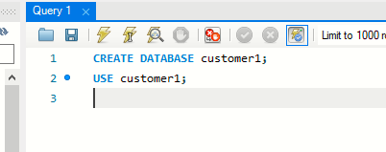

CREATING TABLES

The next step is to create tables in our database. Our project contains 5 different types of tables each with a different primary key. The tables are as follows:

- CATEGORY TABLE

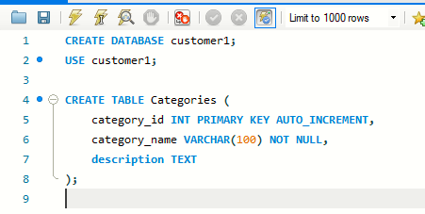

- PRODUCTS TABLE

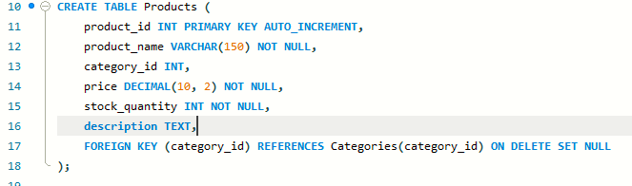

- CUSTOMERS TABLE

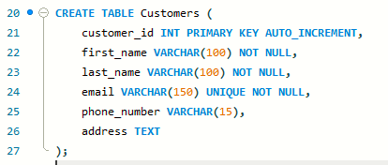

- ORDERS TABLE
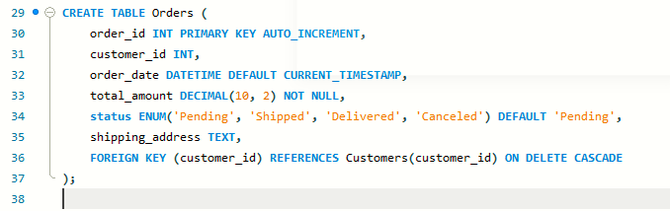

- ORDER_ITEMS TABLE

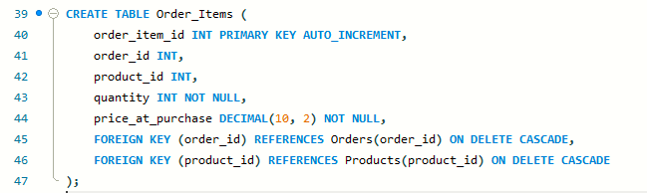

INSERTING THE DATA IN THE TABLES

The next step is to insert the data of all the categories, products, customers, orders and order items. This data would be used to perform various operations and solve multiple queries.

- CATEGORIES TABLE

Here we are dealing with 5 categories:
Electronics, Gadgets, Appliances, Furniture and Books.
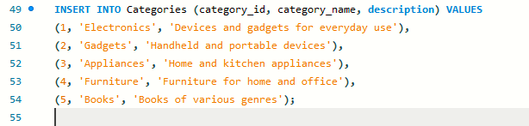

- PRODUCTS TABLE

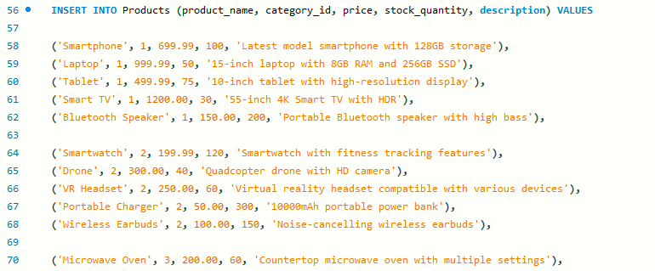

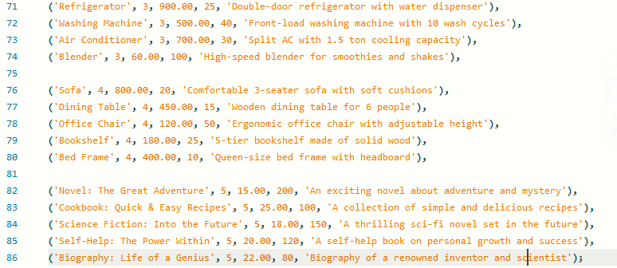

- CUSTOMERS TABLE

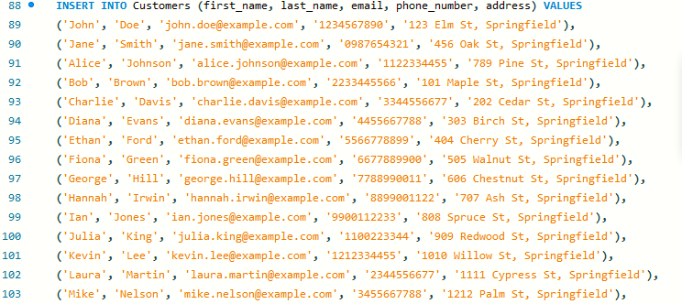

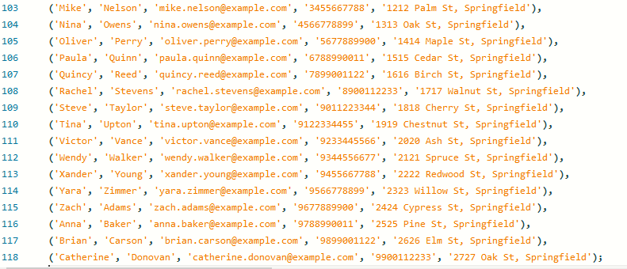

- ORDERS TABLE

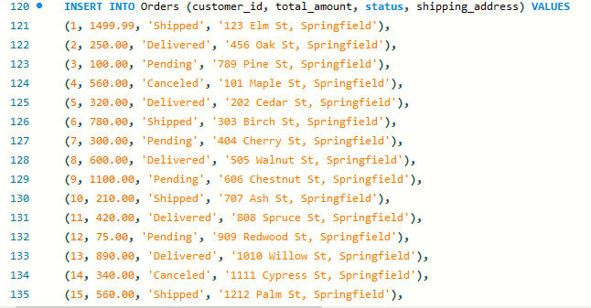

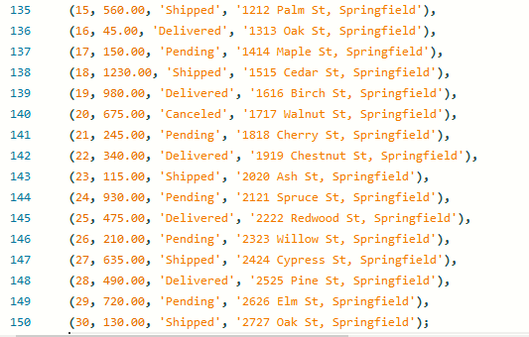

- ORDER_ITEMS TABLE

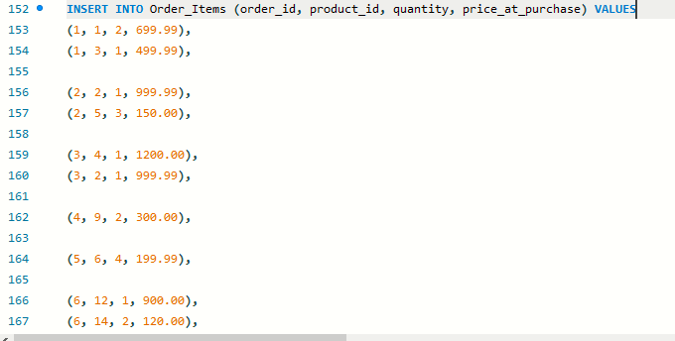

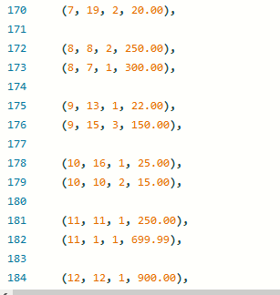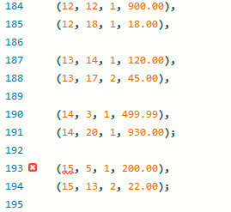

QUERIES

- GET ALL THE PRODUCTS WITH THEIR CATEGORY
SELECT
p.product_id,
p.product_name,
c.category_name,
p.price,
p.stock_quantity
FROM
Products p
JOIN
Categories c ON p.category_id = c.category_id;
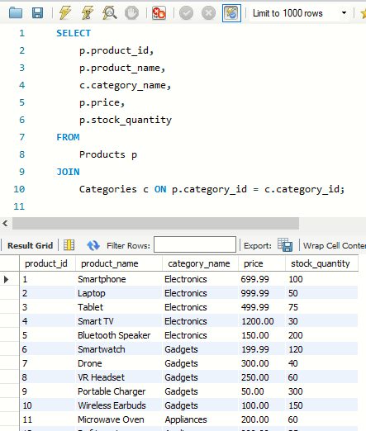
- TOTAL NO. OF ORDERS PER CUSTOMERS
SELECT
c.customer_id,
CONCAT(c.first_name, ' ', c.last_name) AS customer_name,
COUNT(o.order_id) AS total_orders
FROM
Customers c
LEFT JOIN
Orders o ON c.customer_id = o.customer_id
GROUP BY
c.customer_id;

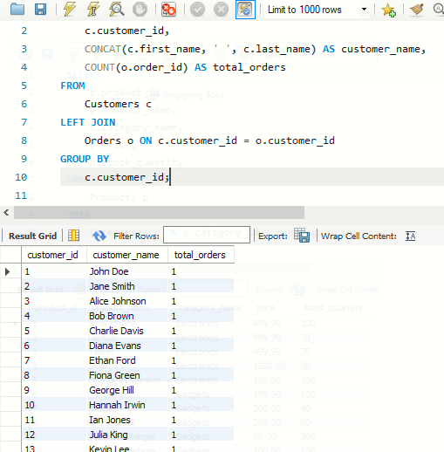
- CALCULATE TOTAL SALES FOR EACH PRODUCT
SELECT
p.product_name,
SUM(oi.quantity) AS total_quantity_sold,
SUM(oi.price_at_purchase * oi.quantity) AS total_sales
FROM
Order_Items oi
JOIN
Products p ON oi.product_id = p.product_id
GROUP BY
p.product_id;

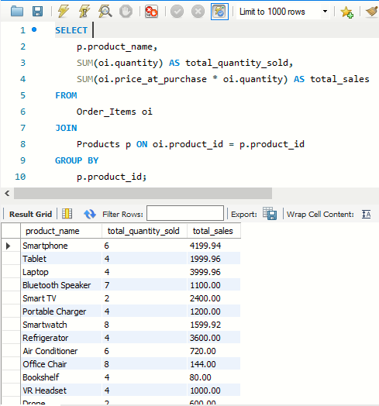
- GET ORDERS WITH ITEM DETAILS
SELECT
o.order_id,
oi.order_item_id,
p.product_name,
oi.quantity,
oi.price_at_purchase
FROM
Orders o
JOIN
Order_Items oi ON o.order_id = oi.order_id
JOIN
Products p ON oi.product_id = p.product_id
ORDER BY
o.order_id;

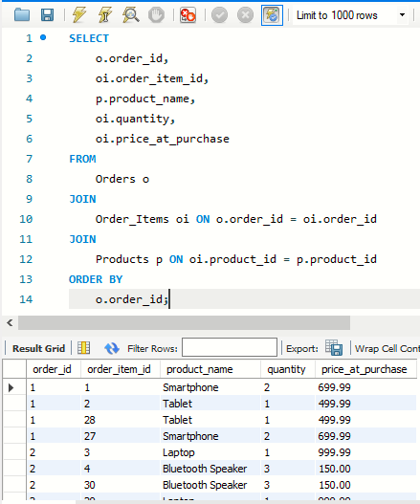
- GET LATEST ORDERS
SELECT
o.order_id,
CONCAT(c.first_name, ' ', c.last_name) AS customer_name,
o.order_date,
o.total_amount
FROM
Orders o
JOIN
Customers c ON o.customer_id = c.customer_id
ORDER BY
o.order_date DESC
LIMIT 10; -- Get the latest 10 orders
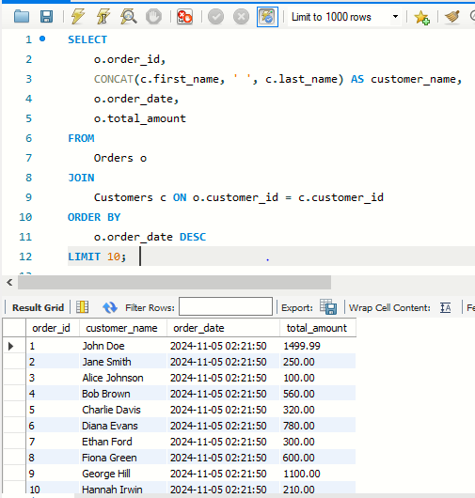
- COUNT OF PRODUCTS IN EACH CATEGORY

SELECT
c.category_name,
COUNT(p.product_id) AS product_count
FROM
Categories c
LEFT JOIN
Products p ON c.category_id = p.category_id
GROUP BY
c.category_id;

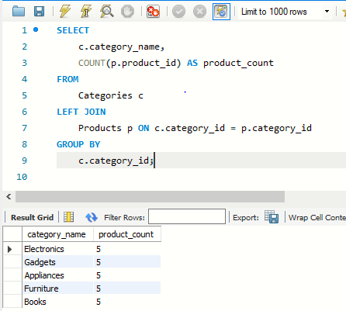

- List all products with their respective category names and descriptions.

SELECT p.product_name, c.category_name, c.description
FROM Products p
JOIN Categories c ON p.category_id = c.category_id;

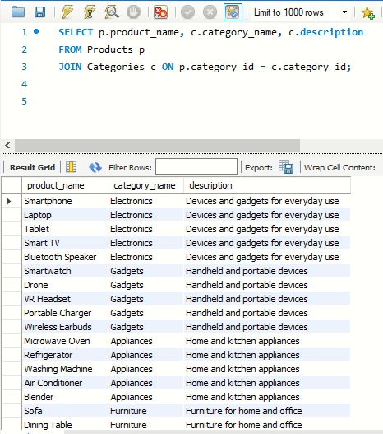

- Get the total amount spent by each customer

SELECT c.customer_id, c.first_name, c.last_name, SUM(o.total_amount) AS total_spent

FROM Customers c

JOIN Orders o ON c.customer_id = o.customer_id
GROUP BY c.customer_id, c.first_name, c.last_name;

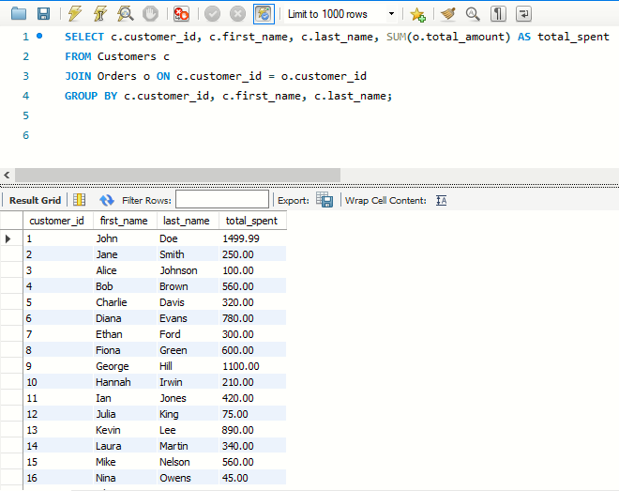

- Find the average product price for each category.

SELECT c.category_name, AVG(p.price) AS avg_price

FROM Categories c

JOIN Products p ON c.category_id = p.category_id

GROUP BY c.category_name;

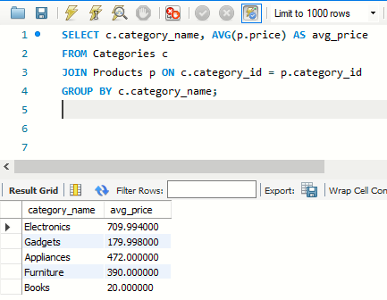

- List customers who haven’t placed any orders.

SELECT c.customer_id, c.first_name, c.last_name

FROM Customers c

LEFT JOIN Orders o ON c.customer_id = o.customer_id
WHERE o.order_id IS NULL;

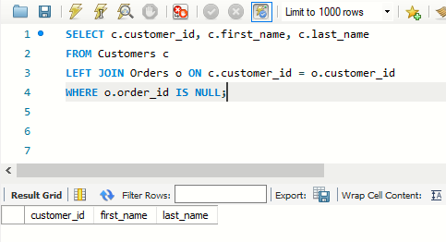

- Show the total revenue generated from each product.

SELECT p.product_name, SUM(oi.quantity * oi.price_at_purchase) AS total_revenue
FROM Products p
JOIN Order_Items oi ON p.product_id = oi.product_id
GROUP BY p.product_name;

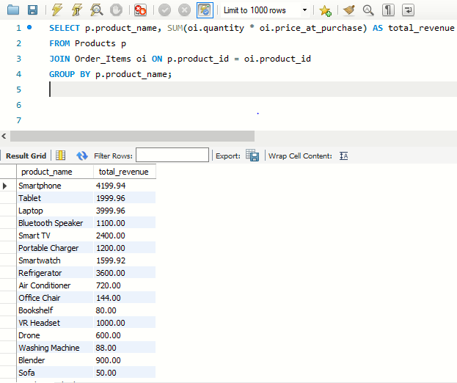

- Update the stock quantity of a product after an order is placed.

UPDATE Products

SET stock_quantity = stock_quantity - (SELECT SUM(quantity) FROM Order_Items WHERE product_id = 1)
WHERE product_id = 1;

Select * from Products;

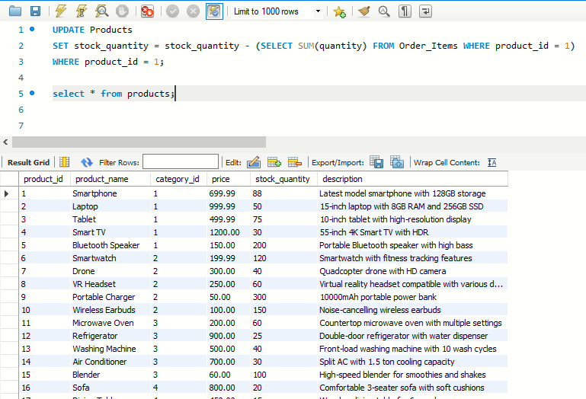

- Find the top 3 products with the highest total revenue.

SELECT p.product_name, SUM(oi.quantity * oi.price_at_purchase) AS total_revenue

FROM Products p

JOIN Order_Items oi ON p.product_id = oi.product_id

GROUP BY p.product_name

ORDER BY total_revenue DESC

LIMIT 3;

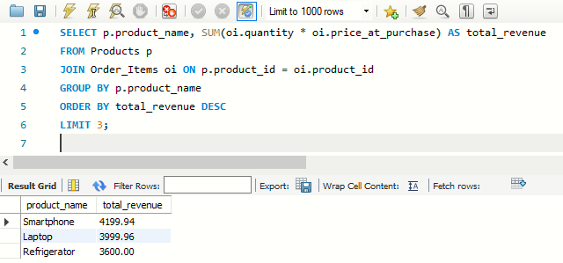

- Calculate the average order amount for each customer.

SELECT c.customer_id, c.first_name, c.last_name, AVG(o.total_amount) AS avg_order_amount

FROM Customers c

JOIN Orders o ON c.customer_id = o.customer_id

GROUP BY c.customer_id, c.first_name, c.last_name;

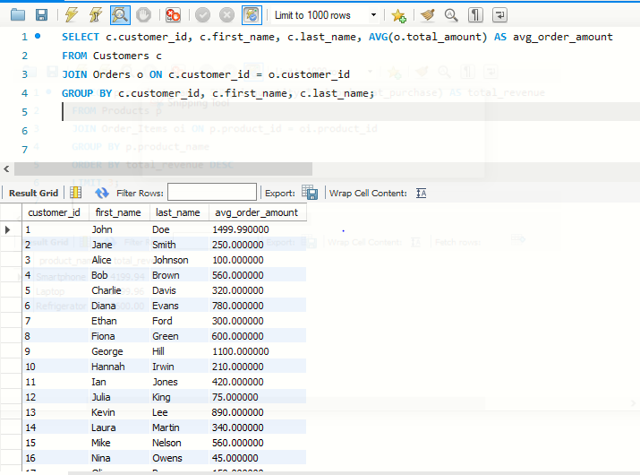

- Get the total number of items sold for each category.

SELECT c.category_name, SUM(oi.quantity) AS total_items_sold

FROM Categories c

JOIN Products p ON c.category_id = p.category_id

JOIN Order_Items oi ON p.product_id = oi.product_id

GROUP BY c.category_name;

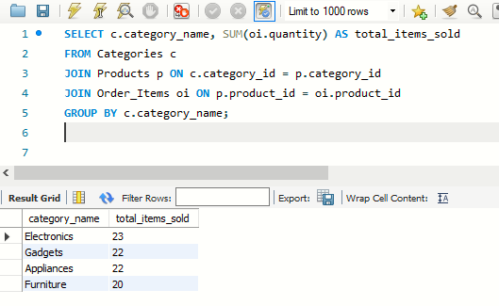

- Find the Most Expensive Product in Each Category

SELECT c.category_name, p.product_name, p.price
FROM products p
JOIN categories c ON p.category_id = c.category_id
WHERE p.price = (
SELECT MAX(price)
FROM products
WHERE category_id = p.category_id
);

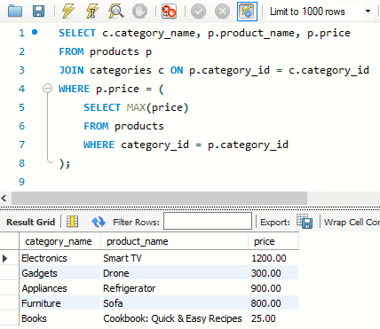

- Get All Orders by a Specific Customer with Order Details

SELECT o.order_id, o.order_date, p.product_name, oi.quantity, oi.quantity * p.price AS item_total
FROM orders o
JOIN order_items oi ON o.order_id = oi.order_id
JOIN products p ON oi.product_id = p.product_id
WHERE o.customer_id = 8; -- Replace with the desired customer ID

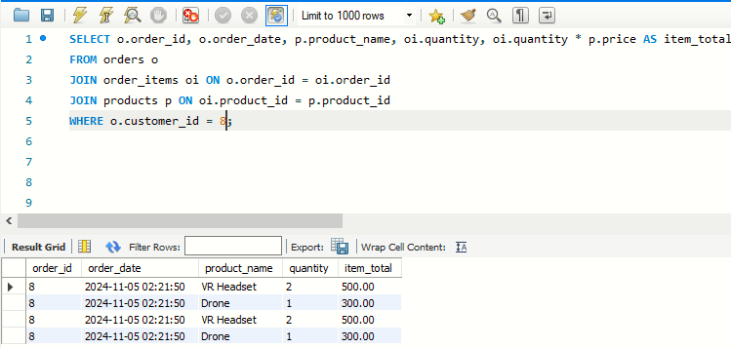

- Get Products That Have Never Been Ordered

SELECT p.product_name
FROM products p
LEFT JOIN order_items oi ON p.product_id = oi.product_id
WHERE oi.order_id IS NULL;

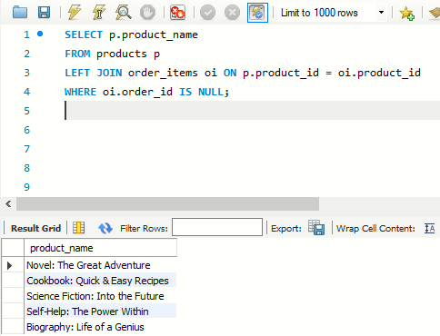

- List All Customers Who Have Purchased More Than a Certain Amount

SELECT o.customer_id, SUM(oi.quantity * p.price) AS total_spent
FROM orders o
JOIN order_items oi ON o.order_id = oi.order_id
JOIN products p ON oi.product_id = p.product_id
GROUP BY o.customer_id
HAVING SUM(oi.quantity * p.price) > 500; -- Replace with the desired amount

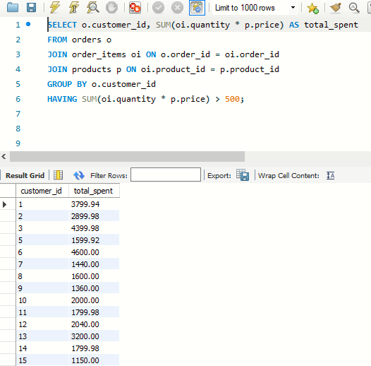

- Update Product Prices in a Specific Category by a Percentage

UPDATE products p
SET p.price = p.price * 1.10 -- Increase prices by 10%
WHERE p.category_id = (
SELECT category_id
FROM categories
WHERE category_name = 'Books' -- Replace with the desired category name
);
Select * from Products where category_id =’5’;

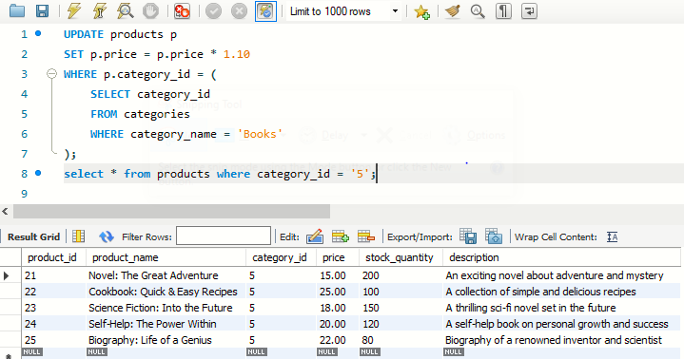

- Trigger to Automatically Update Product Stock After an Order

CREATE OR REPLACE TRIGGER update_product_stock
AFTER INSERT ON order_items
FOR EACH ROW
BEGIN
UPDATE products
SET stock_quantity = stock_quantity - :NEW.quantity
WHERE product_id = :NEW.product_id;
END;

- Trigger to Ensure Stock Quantity is Not Negative

CREATE OR REPLACE TRIGGER check_stock_quantity
BEFORE UPDATE ON products
FOR EACH ROW
BEGIN
IF :NEW.stock_quantity < 0 THEN
RAISE_APPLICATION_ERROR(-20005, 'Stock quantity cannot be negative');
END IF;
END;

- Get Most Popular Products

SELECT p.product_name, COUNT(oi.product_id) AS order_count
FROM order_items oi
JOIN products p ON oi.product_id = p.product_id
GROUP BY p.product_name
ORDER BY order_count DESC;

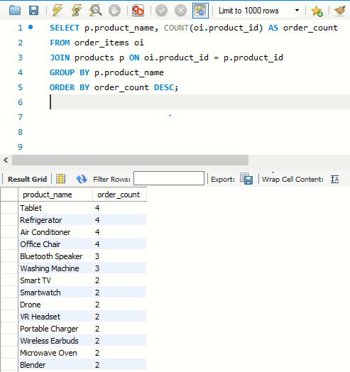

- Get Top 5 Customers by Total Spend

SELECT o.customer_id, SUM(o.total_amount) AS total_spent
FROM orders o
GROUP BY o.customer_id
ORDER BY total_spent DESC
FETCH FIRST 5 ROWS ONLY;

CONCLUSION

In this PL/SQL project for an eCommerce store, we have successfully designed and implemented a database system that supports key functionalities essential for managing an online retail business. The database schema includes the following core tables:
- Customers: Stores customer information such as personal details, contact information, and shipping addresses, ensuring a smooth and personalized shopping experience.
- Products: Contains product details like name, description, price, and stock availability, enabling efficient product management and inventory control.
- Orders: Tracks order details, including customer order history, payment status, and order dates, providing a comprehensive view of each transaction.
- Order Items: A detailed mapping between orders and the products purchased, allowing for accurate order processing and inventory tracking.
- Categories: Organizes products into categories for improved browsing and search functionality, helping customers find products based on their interests.
By utilizing PL/SQL, we have implemented various stored procedures, triggers, and functions to enhance the performance and reliability of the system. For instance, stored procedures automate complex queries and transactions, while triggers ensure data integrity by enforcing business rules (e.g., checking stock availability before order confirmation). Functions were used to calculate order totals and generate reports for business insights.
This project also demonstrates how a well-structured database design, combined with PL/SQL’s capabilities, can provide an efficient backend solution for an eCommerce platform. With the ability to manage and query large amounts of data quickly, the system ensures that both customers and administrators can interact with the store seamlessly.
In conclusion, the database design and PL/SQL implementation create a solid foundation for running an eCommerce store, handling everything from customer interactions to inventory and order management. Future enhancements could include additional features like customer reviews, discount management, or integration with external payment systems, but this project successfully covers the core requirements of a typical online store.

